**Introduction**

This secondary analysis used data from the Multicenter AIDS Cohort Study (MACS), a prospective cohort study of Human Immunodeficiency Virus (HIV) infection with annual follow-up. The investigator provided longitudinal laboratory and survey data, and this analysis focused on baseline (Year 0, last untreated visit prior to HAART initiation) and Year 2 outcomes during treatment. Available variables included viral load, CD4+ T-cell count, quality-of-life measures, demographic characteristics, behavioral factors, and treatment adherence.

The primary objective was to determine whether baseline hard drug use (injection drug use or illicit heroin/opiate use) was associated with poorer two-year treatment response. We hypothesized that participants reporting baseline hard drug use would have higher viral load, lower CD4 count, and lower physical and mental quality-of-life (QOL) scores at Year 2 compared to non-users. Because adherence may influence these relationships, we additionally examined models adjusting for Year 2 adherence.

**Methods**

**Study Sample:** The original dataset contained up to eight years of follow-up (Years 0–8). For this analysis, data were restricted to baseline (Year 0) and Year 2. Data were reshaped into wide format to create one observation per participant. Participants were included if they had baseline and Year 2 measurements for the outcome of interest. Descriptive analyses included N = 476 participants. Bayesian regression models were fit on complete-case observations for all variables included in each model, yielding a final analytic sample of N = 463.The participant derivation process is illustrated in Appendix Figure A1.

The primary laboratory outcomes were viral load (VLOAD, HIV RNA copies/mL), and CD4+ T-cell count (cells/µL), a measure of immunological function. Health-related quality of life outcomes, physical and mental quality of life, were assessed using the SF-36 instrument. The primary exposure was baseline hard drug use (Yes/No). Year 2 adherence was dichotomized as ≥95% vs <95% and included in exploratory models.

**Data Management:** Special missing value codes were recorded as missing. During preliminary data inspection, extreme Body Mass Index (BMI) values (> 70 kg/m²) were identified. In consultation with the principal investigator, these values were deemed implausible and were therefore set to missing. Viral load was log₁₀-transformed to reduce skewness and improve adherence to linear regression model assumptions. CD4 count and quality-of-life measures were analyzed on their original scales. Race was dichotomized as White, non-Hispanic versus Other race, and education was categorized as college degree or higher versus No college degree.

**Preliminary Analyses**: Baseline characteristics were summarized overall and stratified by baseline hard drug use status (Table 1). Continuous variables were summarized using mean and standard deviation; categorical variables were summarized using counts and percentages. Outcome distributions at baseline and Year 2 were examined visually using histograms (Appendix Figures A2–A3). Year 2 adherence distributions by baseline hard drug use were summarized (Appendix Figure A4).

**Frequentist Analysis:** For each outcome, multivariable linear regression models estimated the association between baseline hard drug use and the Year 2 outcome. Models adjusted for the corresponding baseline outcome value, age, BMI, smoking status, education, and race. Exploratory models additionally adjusted for Year 2 adherence. Model assumptions were evaluated using residual-versus-fitted plots, Q–Q plots, scale-location plots, and leverage diagnostics (Appendix Figures A5–A12). Statistical significance was defined as α = 0.05.

**Bayesian Analysis:** Bayesian linear regression models were fit using the same covariate structure as the frequentist analyses. Viral load was modeled on the log₁₀ scale, while CD4 count and QOL outcomes were modeled on their original scales. Regression coefficients were assigned weakly informative Normal (0, 100²) priors, and the residual standard deviation was assigned an outcome-scaled Half-Normal prior, σ ~ Half-Normal (0, s), where s = SD(y). Models were estimated using Hamiltonian Monte Carlo with the No-U-Turn Sampler (NUTS) in Stan via *cmdstanr*, with four chains and 2,000 post-warmup iterations per chain. Convergence was assessed using trace plots, autocorrelation plots, Gelman–Rubin statistics (R̂ ≈ 1), and effective sample sizes (ESS > 1000). Posterior means and 95% highest density intervals (HDIs) were reported for the hard drug use effect, along with posterior probabilities of clinically meaningful effects, defined as P(|β_drug| > γ | data), where γ was 0.5 log₁₀ units for viral load, 50 cells/µL for CD4 count, and 2 points for QOL. Model fit was summarized using Widely Applicable Information Criterion (WAIC) and Deviance Information Criterion (DIC). Models including Year 2 adherence were considered exploratory because adherence may lie on the causal pathway.

**Results**

A total of 476 participants were included, of whom 39 (8.2%) reported baseline hard drug use. Mean age was similar between users and non-users (44.6 ± 9.5 vs. 43.1 ± 8.7 years). Hard drug users had lower BMI (23.6 ± 3.5 vs. 25.3 ± 4.4 kg/m²; 13 BMI values missing overall), were more likely to be current smokers (76.9% vs. 35.5%), less likely to have completed college (25.6% vs. 44.6%), and more likely to identify as non-White (51.3% vs. 36.1%). Baseline viral load was identical between groups (4.52 ± 0.86 vs. 4.52 ± 0.93 log₁₀ copies/mL), while CD4 count was slightly lower among users (352 ± 195 vs. 375 ± 201 cells/mL). Physical (47.7 ± 8.5 vs. 51.3 ± 9.1) and mental (42.3 ± 11.2 vs. 45.1 ± 13.7) quality-of-life scores were also lower among users. Year 2 adherence ≥95% was observed in 38 participants with baseline hard drug use and 416 participants without baseline hard drug use; adherence <95% was observed in 1 and 51 participants, respectively. Adherence was missing for 27 hard drug users and 182 non-users (Appendix Figure A4).

In multivariable adjusted models (N = 463), baseline hard drug use was not associated with Year 2 viral load (Table 2). In contrast, baseline hard drug use was associated with substantially lower Year 2 CD4 count and lower physical QoL. Specifically, hard drug users had 164 fewer CD4 cells/µL at Year 2 (95% CI: −227 to −102; p < 0.001) and 3.32 points lower physical QoL (95% CI: −6.06 to −0.58; p = 0.018). No association was observed for mental QoL (−0.49; 95% CI: −3.97 to 2.99; p = 0.77). Additional adjustment for adherence did not materially change effect estimates (Table 2). Model diagnostics indicated no major violations of linear regression assumptions (Appendix Figures A5–A12; Table A1).

Bayesian regression results (Table 3; Figure 1) were consistent with the frequentist analyses. For Year 2 viral load, posterior mean differences were −0.028 log₁₀ units (95% HPDI: −0.436 to 0.359) in the adjusted model and 0.017 (95% HPDI: −0.365 to 0.431) after adjustment for adherence. In both models, HPDIs included zero and the posterior probability of exceeding the clinically meaningful threshold (0.5 log₁₀ units) was ≤ 0.02, indicating minimal evidence of a meaningful association. In Figure 1, the viral load estimates are centered near zero, with horizontal intervals clearly crossing the null line (showing absence of effect). In contrast, strong posterior evidence supported lower Year 2 CD4 count among participants reporting baseline hard drug use. Posterior mean reductions were −148 cells/µL (95% HPDI: −209 to −88) and −153 cells/µL (95% HPDI: −209 to −94) in the adjusted and adherence-adjusted models, respectively, with posterior probability of exceeding the 50 cells/µL threshold equal to 0.99. In Figure 1, both CD4 estimates lie entirely below zero, and their intervals do not cross the null line, visually demonstrating a consistent and clinically meaningful reduction.

Baseline hard drug use was also associated with lower physical quality of life (−3.33 and −3.57 points; HPDIs excluding zero), with posterior probabilities of exceeding the 2-point clinical threshold ranging from 0.84 to 0.87. In Figure 1, these estimates appear moderately below zero with intervals narrowly excluding the null, indicating a smaller but still meaningful effect. In contrast, associations with mental quality of life were small and uncertain (−0.50 and −0.74), with HPDIs including zero and posterior probabilities ≤ 0.31; correspondingly, Figure 1 shows intervals crossing zero, reflecting substantial uncertainty. Model fit statistics (WAIC/DIC) were similar across models, indicating little improvement with additional adjustment for adherence.

**Discussion/Conclusion**

In this secondary analysis of MACS data, baseline hard drug use was associated with worse outcomes at Year 2. Participants who reported hard drug use had substantially lower CD4 counts (approximately 150 cells/µL lower) and lower physical quality-of-life scores, even after adjusting for baseline values and other demographic and behavioral factors. The Bayesian analysis showed a 99% probability that the CD4 reduction exceeded 50 cells/µL and more than 80% probability that the physical quality-of-life difference exceeded the 2-point clinical threshold, supporting a clinically meaningful effect.

In contrast, there was no clear evidence that baseline hard drug use was associated with Year 2 viral load or mental quality of life. For these outcomes, the posterior intervals included zero and the probability of clinically meaningful differences was low. Adjustment for Year 2 adherence did not substantially change the findings, suggesting that factors beyond adherence may contribute to poorer immune recovery and physical well-being.

This study has several limitations. The analysis was restricted to participants with complete data, hard drug use was self-reported, and residual confounding is possible. In addition, missing adherence data limited conclusions about its role. Overall, results were consistent across frequentist and Bayesian approaches and supported by appropriate model diagnostics.

**Table 1. Baseline demographic, behavioral, laboratory, and quality-of-life characteristics of participants at Year 0, stratified by baseline hard drug use (Yes vs. No).**

Continuous variables are presented as mean (SD); categorical variables are presented as n (% within exposure group). All variables were measured at baseline prior to HAART initiation.

|  | **Hard Drug Use (N=39)** | **No Hard Drug Use (N=437)** | **Overall (N=476)** |
| --- | --- | --- | --- |
| **Age (Mean, SD)** | 44.62 (9.49) | 43.14 (8.65) | 43.26 (8.72) |
| **Body Mass Index (kg/m²) (Mean, SD)** | 23.62 (3.45) | 25.34 (4.39) | 25.21 (4.34) |
| Missing (n) | 3 | 10 | 13 |
| **Smoking (N, %)** |  |  |  |
| Never smoked | 0 | 139 (31.8%) | 139 |
| Former smoker | 9 (23.1%) | 143 (32.7%) | 152 |
| Current smoker | 30 (76.9%) | 155 (35.5%) | 185 |
| **Education (N, %)** |  |  |  |
| No college degree | 29 (74.4%) | 242 (55.4%) | 271 |
| College and above | 10 (25.6%) | 195 (44.6%) | 205 |
| **Race (N, %)** |  |  |  |
| White, non-Hispanic | 19 (48.7%) | 279 (63.8%) | 298 |
| Other race | 20 (51.3%) | 158 (36.1%) | 178 |
| **Log10 Viral Load, (Mean, SD)** | 4.52 (0.86) | 4.52 (0.93) | 4.52 (0.92) |
| **Number of CD4 Positive Cells (cells/ µL), (Mean, SD)** | 352.18 (194.67) | 375.44 (201.07) | 373.53 (200.46) |
| **Physical Quality of Life Score, (Mean, SD)** | 47.70 (8.50) | 51.34 (9.05) | 51.04 (9.05) |
| **Mental Quality of Life Score, (Mean, SD)** | 42.31 (11.22) | 45.12 (13.68) | 44.89 (13.50) |

**Table 2. Frequentist linear regression estimates for the association between baseline hard drug use and Year 2 outcomes.**Estimates represent adjusted regression coefficients (β) comparing participants reporting baseline hard drug use to non-users. The Adjusted model includes baseline outcome value, age, body mass index, smoking status, education, and race. The Adjusted + Adherence model additionally includes Year 2 adherence (≥95% vs <95%). Two-sided 95% confidence intervals and p-values are reported.

|  |  |  |  |  |
| --- | --- | --- | --- | --- |
| **Outcome** | **Adjusted estimate**  **(95% CI)** | **P-value** | **Adjusted + Adherence estimate (95% CI)** | **P-value** |
| Log10 Viral Load at Year 2 | -0.030 (-0.428, 0.369) | 0.88 | 0.017 (-0.382, 0.415) | 0.935 |
| CD4 Positive Cells at Year 2 | -164.384 (-227.164, -101.604) | <0.001 | -170.146 (-232.988, -107.304) | <0.001 |
| Physical QOL at Year2 | -3.321 (-6.061, -0.581) | 0.018 | -3.551 (-6.296, -0.806) | 0.011 |
| Mental QOL at Year2 | -0.491 (-3.968, 2.986) | 0.77 | -0.729 (-4.216, 2.758) | 0.681 |

**Table 3. Posterior mean estimates and 95% highest posterior density intervals (HPDIs) for the association between baseline hard drug use and Year 2 outcomes from Bayesian linear regression models.**Models include the same covariates as Table 2. Clinically meaningful thresholds (γ) were prespecified as 0.5 log₁₀ units for viral load, 50 cells/µL for CD4 count, and 2 points for quality of life. Posterior probability P(|β| > γ) represents the probability that the magnitude of association exceeds the clinically meaningful threshold. Model fit was evaluated using the WAIC and DIC.

|  |  |  |  |  |  |  |
| --- | --- | --- | --- | --- | --- | --- |
| **Outcome** | **Model** | **WAIC** | **DIC** | **Posterior Mean (β)** | **95% HPDI (Lower, Upper)** | **P(|β| > γ)** |
| Log10 Viral Load at Year 2 | Adjusted | 1439.3 | 1438.44 | -0.028 | (-0.436, 0.359) | 0.016 |
| Log10 Viral Load at Year 2 | Adjusted + ADH | 1435.4 | 1434.22 | 0.017 | (-0.365, 0.431) | 0.012 |
| CD4 Count at Year 2 | Adjusted | 6126.4 | 6123.29 | -148.399 | (-208.554, -87.992) | 0.99 |
| CD4 Count at Year 2 | Adjusted + ADH | 6124.1 | 6121.2 | -152.973 | (-209.429, -94.478) | 0.99 |
| Physical QOL at Year 2 | Adjusted | 3225.5 | 3223.44 | -3.332 | (-6.150, -0.790) | 0.835 |
| Physical QOL at Year 2 | Adjusted + ADH | 3223.9 | 3222.12 | -3.567 | (-6.339, -0.964) | 0.872 |
| Mental QOL at Year 2 | Adjusted | 3444.8 | 3442.85 | -0.497 | (-4.002, 2.968) | 0.278 |
| Mental QOL at Year 2 | Adjusted + ADH | 3444.5 | 3442.29 | -0.742 | (-4.290, 2.803) | 0.308 |

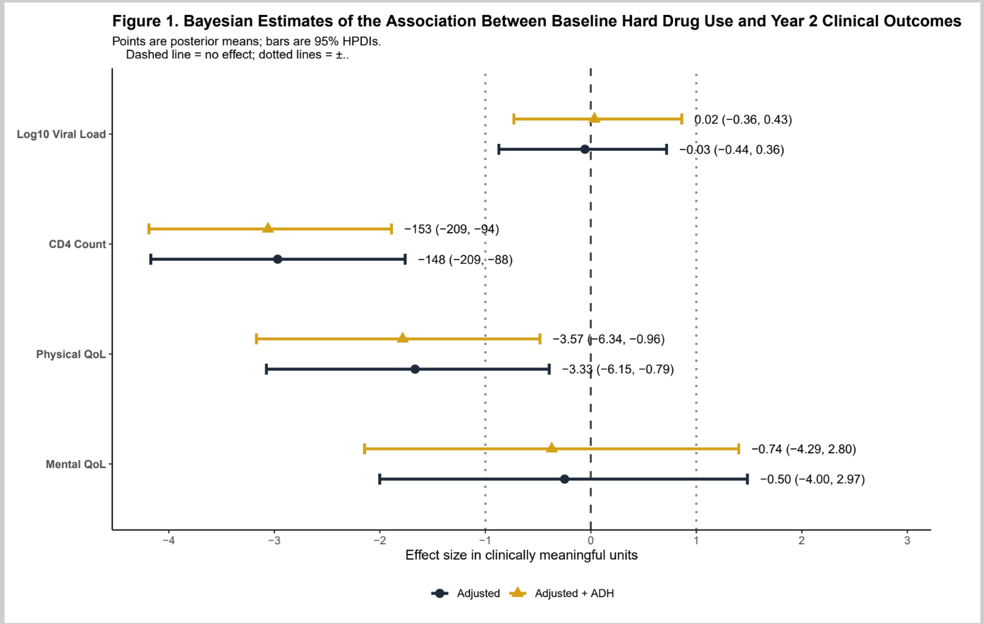

**Raw Data**

**C:\Users\mojde\Desktop\Documents\BIOS-6624-Projects\Project1\DataRaw**

**Processed Data**

**C:\Users\mojde\Desktop\Documents\BIOS-6624-Projects\Project1\DataProcessed**

**R code**

[**https://github.com/mojdemir/BIOS-6624-Projects/tree/main/Project1/Code**](https://github.com/mojdemir/BIOS-6624-Projects/tree/main/Project1/Code)

**Appendix**

**Figure A1. Participant flow diagram illustrating derivation of analytic samples from the original longitudinal cohort.**

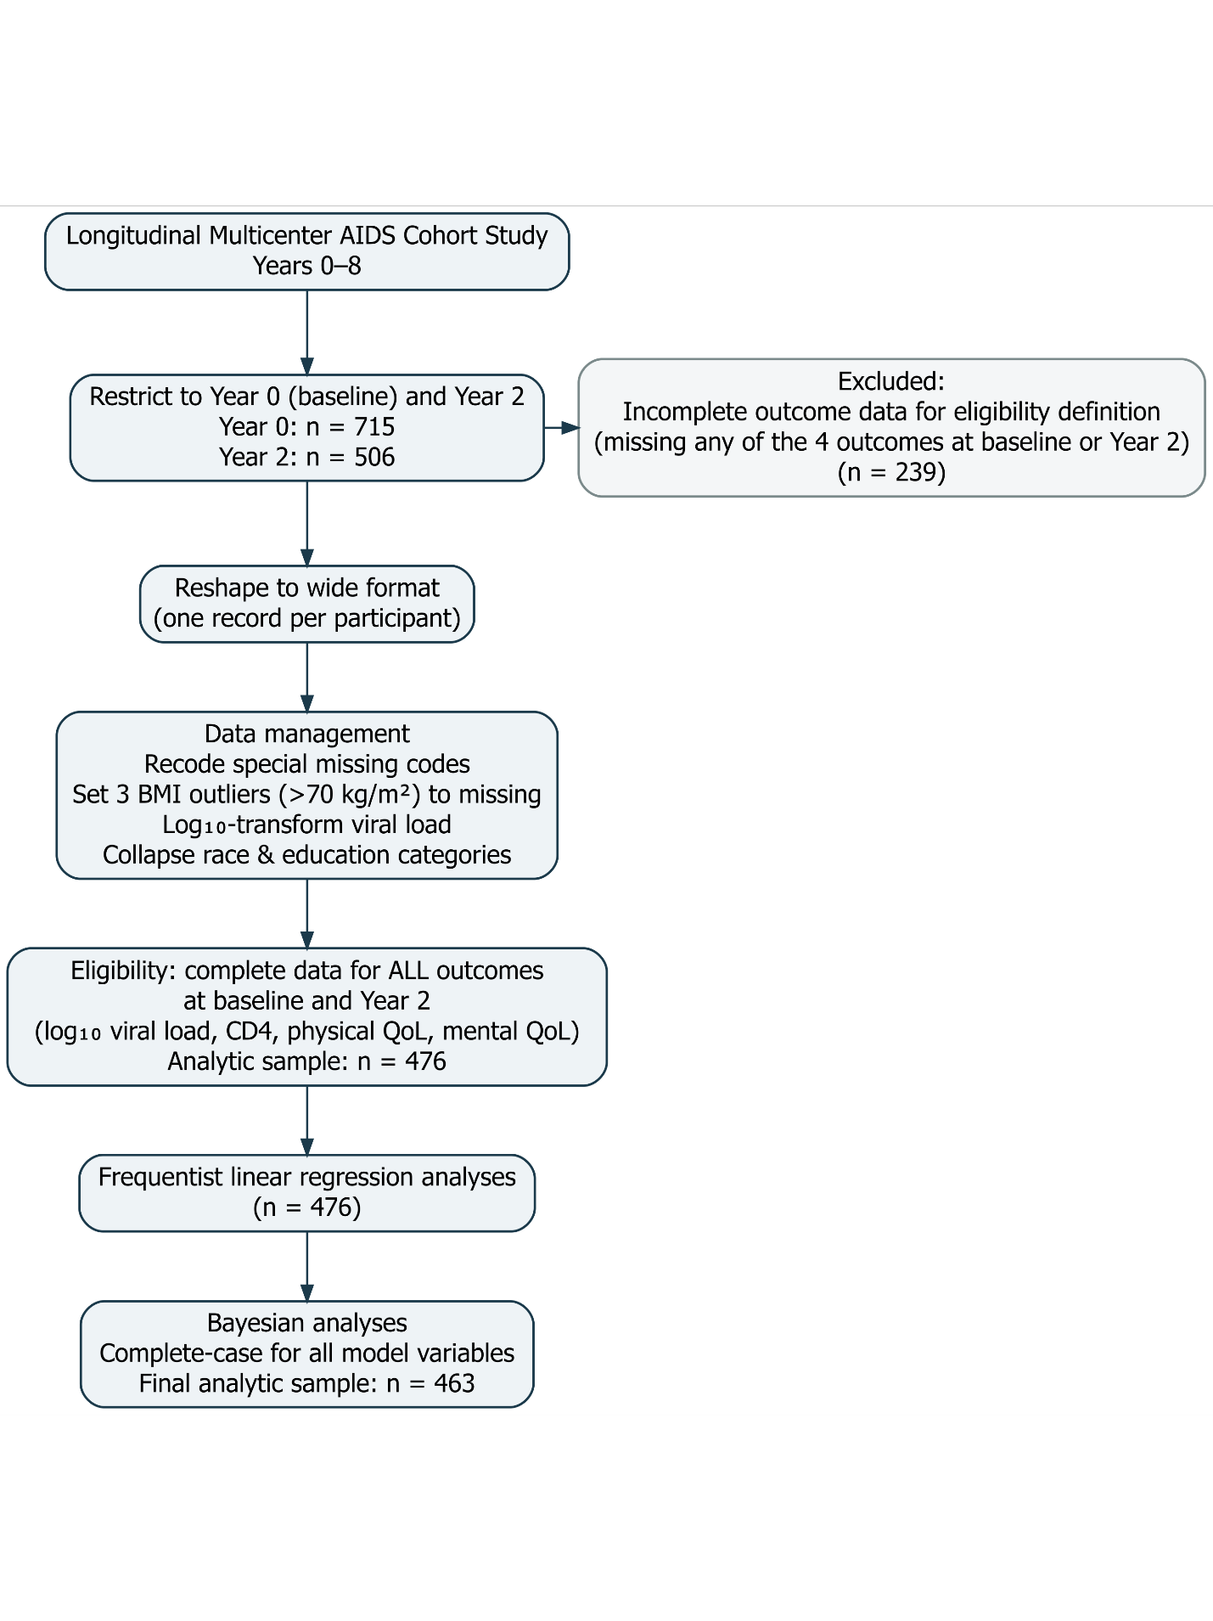

**Figure A2. Distributions of Baseline and Year 2 Outcomes**

Histograms display the distributions of viral load, CD4 cell count, and physical and mental quality-of-life scores at baseline (Year 0) and Year 2. Viral load values are presented on the original scale as recorded in the dataset. Scales differ across panels to reflect the natural range of each outcome. The histograms show marked right-skewness for viral load and approximately symmetric distributions for CD4 count and quality-of-life measures.

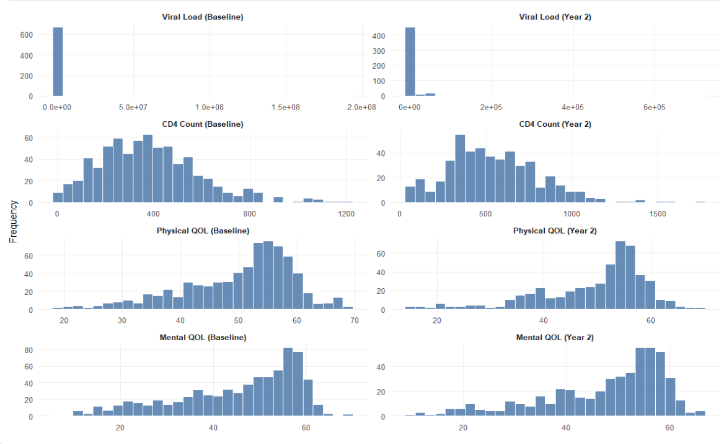

**Figure A3. Distribution of log₁₀ Viral Load at Baseline and Year 2**

Histograms display the distribution of log₁₀-transformed viral load at baseline (Year 0) and Year 2. The log transformation reduces the strong right-skewness observed when viral load is measured on the original scale. Following transformation, the distributions appear approximately symmetric, supporting the use of linear regression models in subsequent analyses.

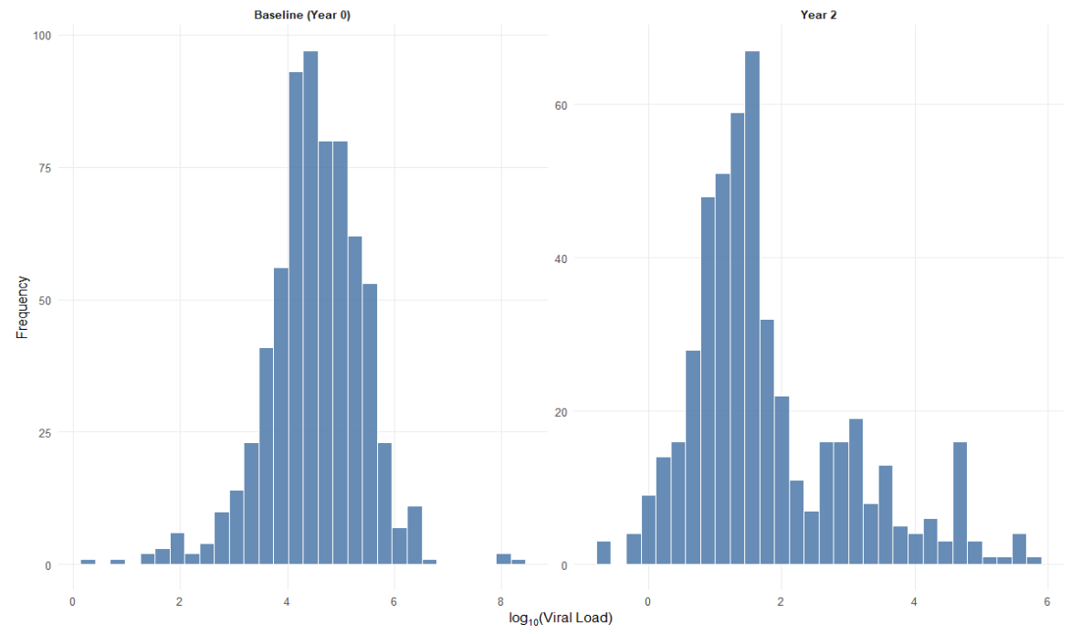

**Figure A4. Year 2 Adherence by Baseline Hard Drug Use Status**

The bar chart shows the number of participants in each Year 2 adherence category, stratified by baseline hard drug use status. Counts are displayed above each bar. Within each adherence category, participants reporting baseline hard drug use are presented first.

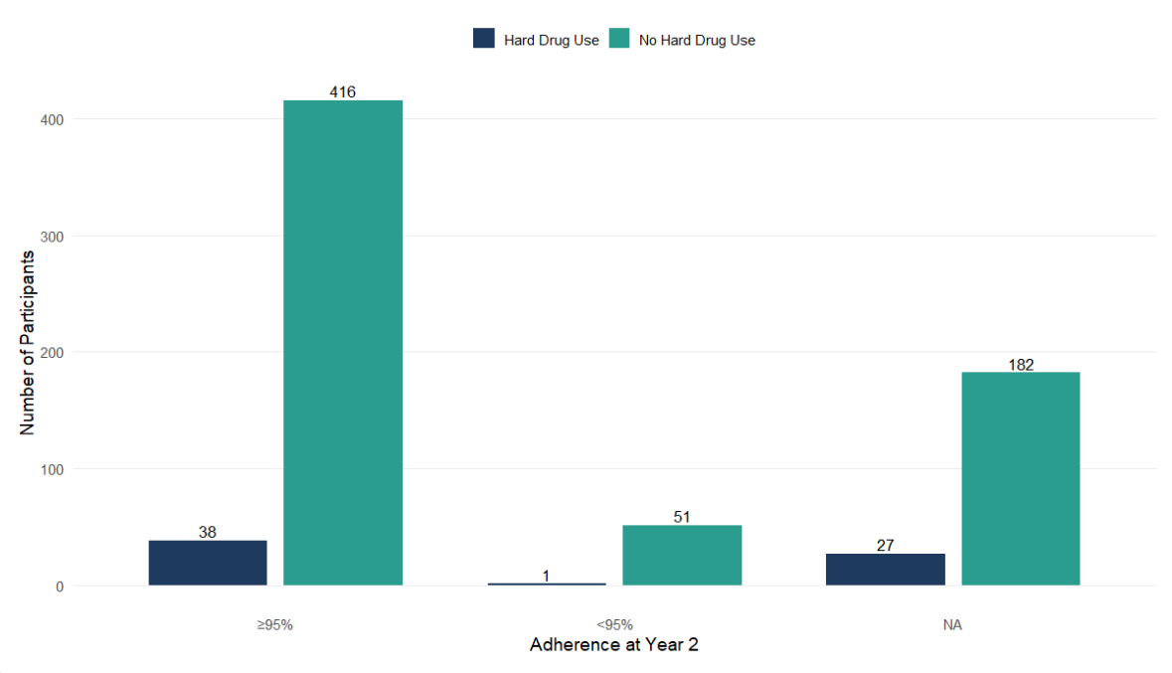

**Figures A5-A12. Diagnostic Tests**

Results of diagnostic tests for regression model assumptions are presented below. These include assessments of linearity, normality of residuals, homoscedasticity, and influential observations. No substantial deviations from linearity, normality, or homoscedasticity were observed in residual diagnostics.

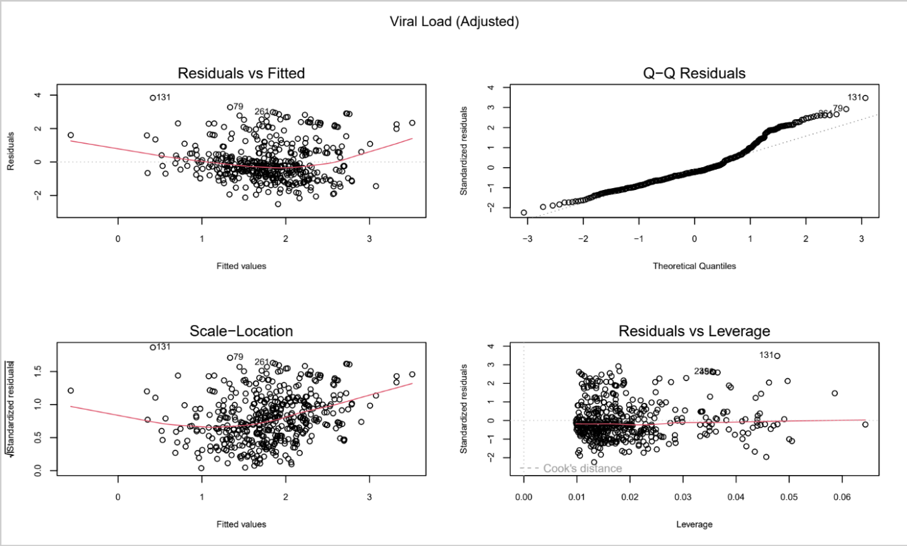

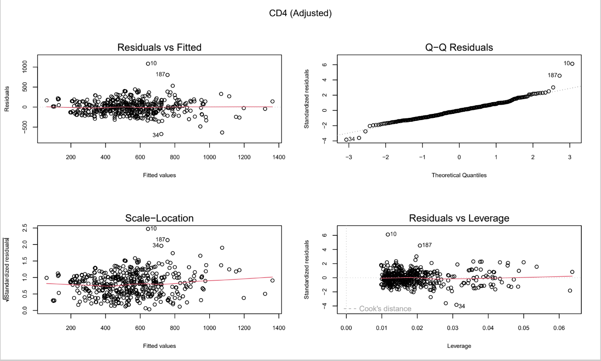

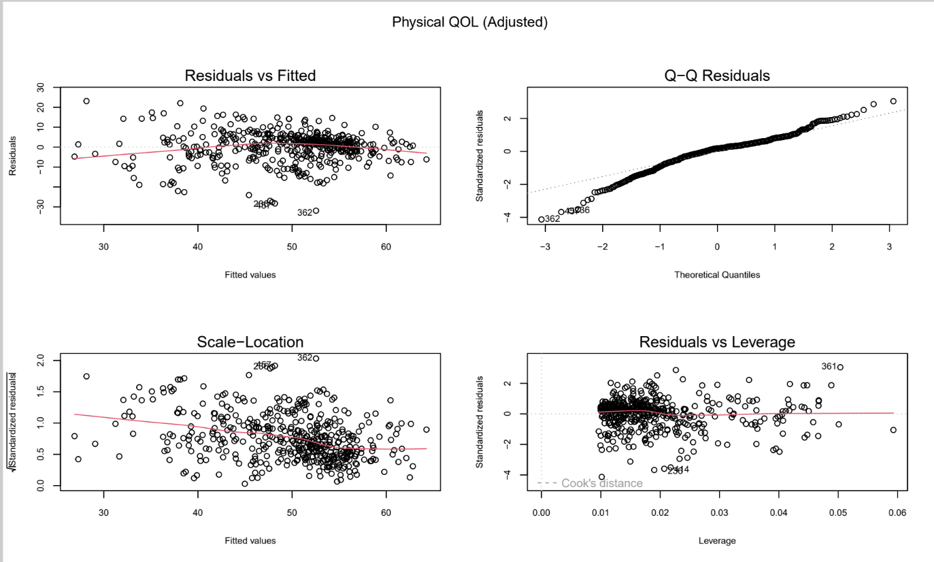

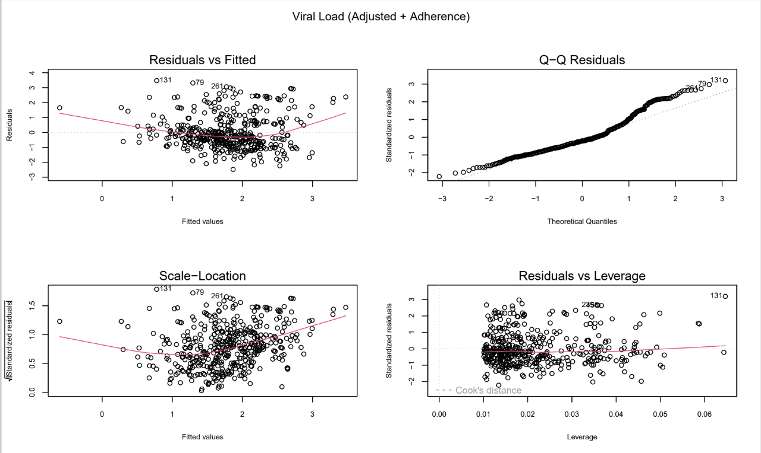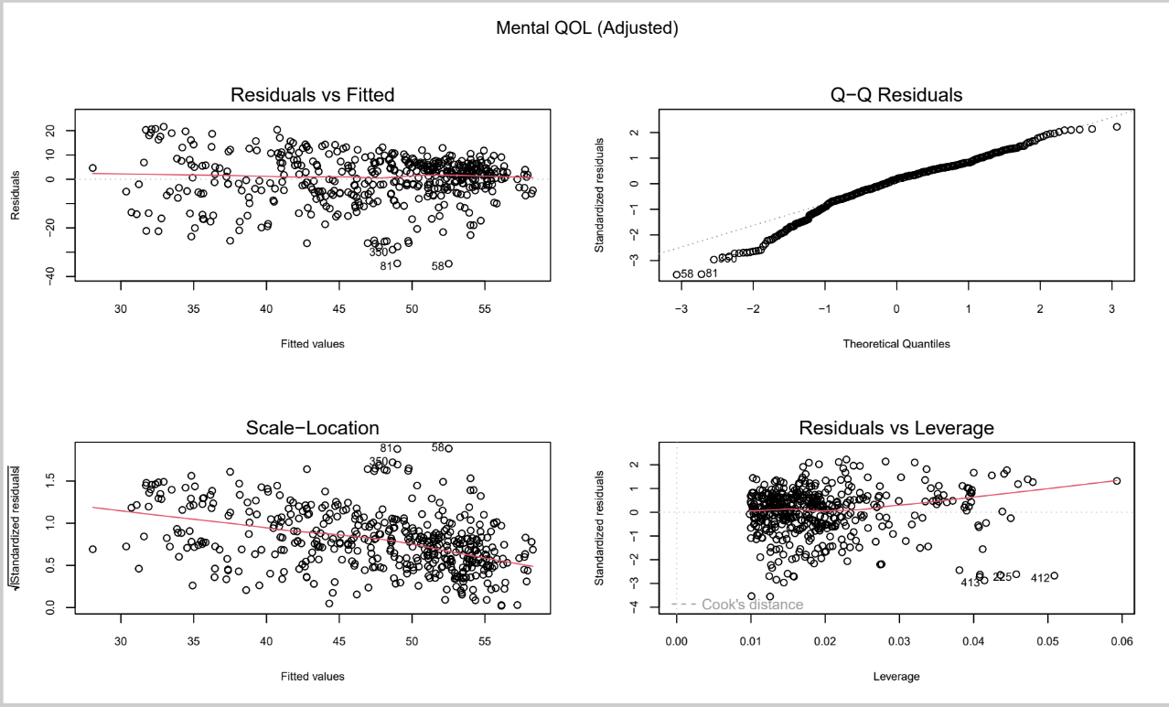

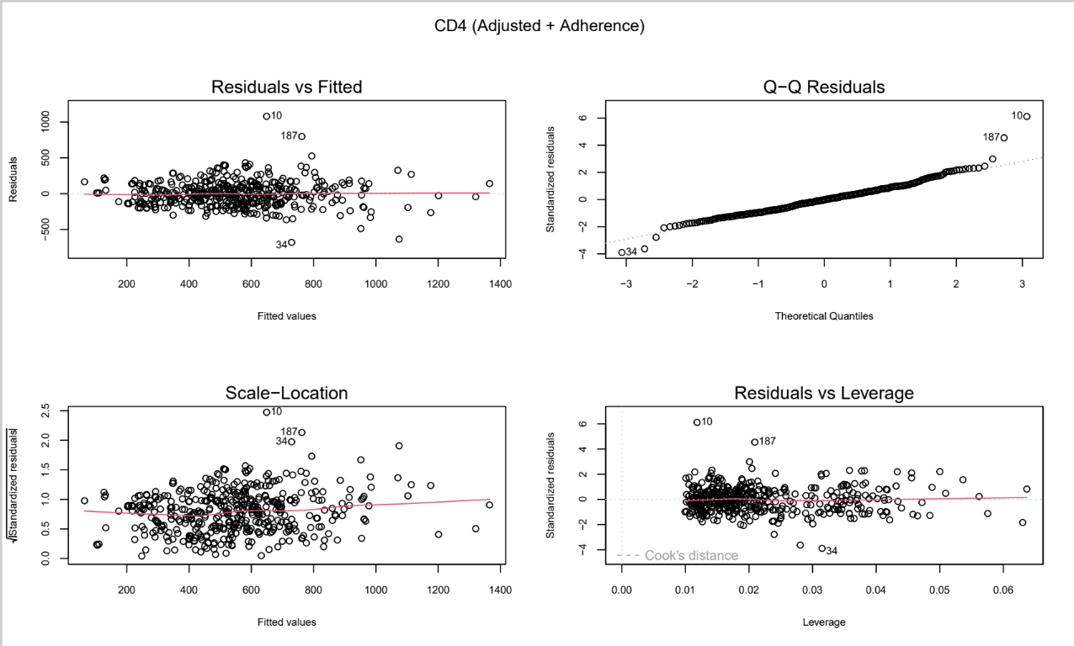

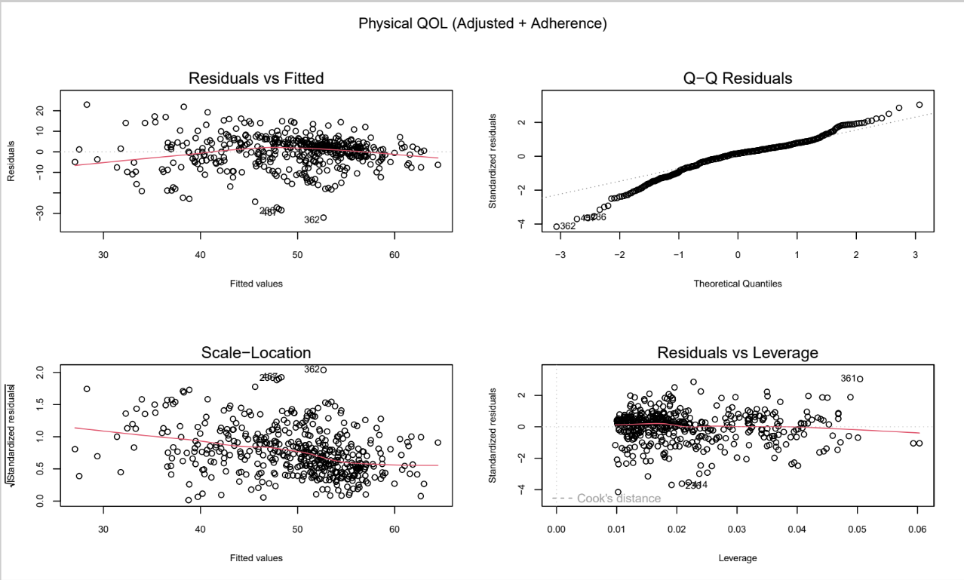

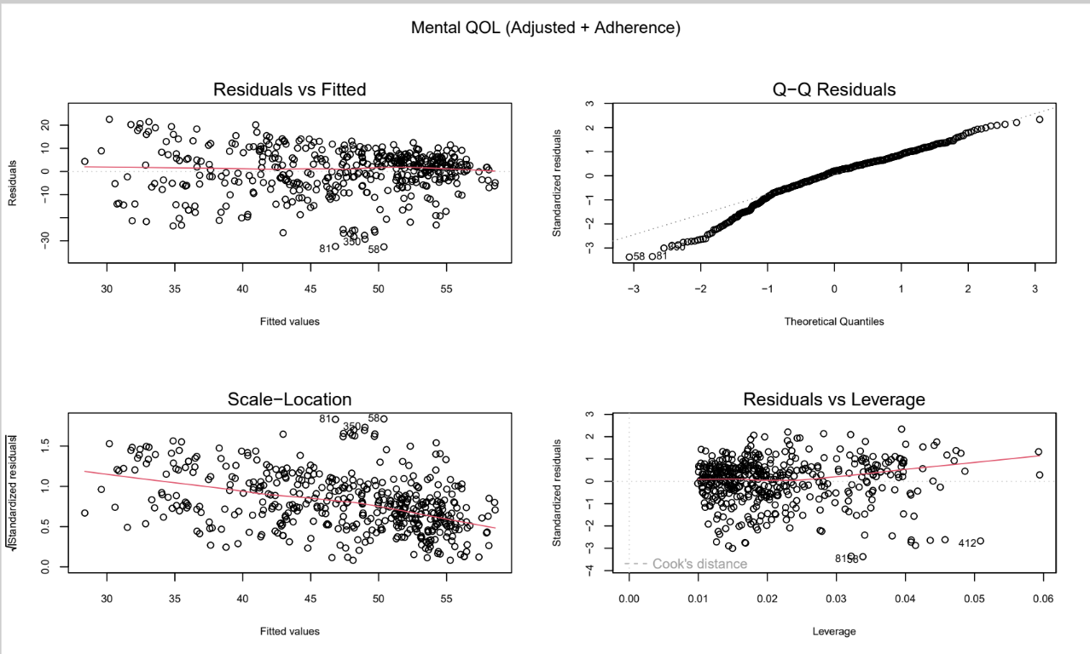

**Table A1. Model fit statistics for frequentist regression models predicting viral load, CD4 count, and physical and mental quality of life (QOL) outcomes (N = 463).** The “Adjusted” models include covariate adjustments only, whereas the “Adjusted + Adherence” models additionally incorporate adherence as a covariate. Reported statistics include R², adjusted R², and root mean square error (RMSE). Across outcomes, inclusion of adherence results in modest improvements in explained variance (R² and adjusted R²) and slight reductions in RMSE, indicating improved model fit.

|  |  |  |  |
| --- | --- | --- | --- |
| **Model** | **R²** | **Adjusted R²** | **RMSE** |
| Viral Load (Adjusted) | 0.1706 | 0.1560 | 1.1195 |
| CD4 (Adjusted) | 0.5639 | 0.5562 | 176.3097 |
| Physical QOL (Adjusted) | 0.4298 | 0.4197 | 7.6947 |
| Mental QOL (Adjusted) | 0.3336 | 0.3219 | 9.7476 |
| Viral Load (Adjusted + Adherence) | 0.1817 | 0.1655 | 1.1120 |
| CD4 (Adjusted + Adherence) | 0.5676 | 0.5591 | 175.5540 |
| Physical QOL (Adjusted + Adherence) | 0.4338 | 0.4226 | 7.6672 |
| Mental QOL (Adjusted + Adherence) | 0.3369 | 0.3237 | 9.7241 |

**Model Performance (A13- A36)**

Convergence diagnostics for all Bayesian models are presented in Appendix Figures A13–A36 and Table A2. Autocorrelation function (ACF) plots for all model parameters demonstrated rapid decay, indicating low autocorrelation and efficient posterior exploration under the Hamiltonian Monte Carlo No-U-Turn Sampler (NUTS). Trace plots from the four chains (2,000 post-warmup iterations per chain) showed stable, well-mixed sampling with no visible trends or chain separation, supporting convergence. Posterior density plots were nearly identical across chains and exhibited smooth, unimodal distributions without irregularities. Consistent with these visual assessments, Gelman–Rubin statistics were approximately 1.00 and effective sample sizes exceeded 1,000 for all parameters, indicating adequate convergence and reliable posterior estimation.

**Viral Load adjusted**

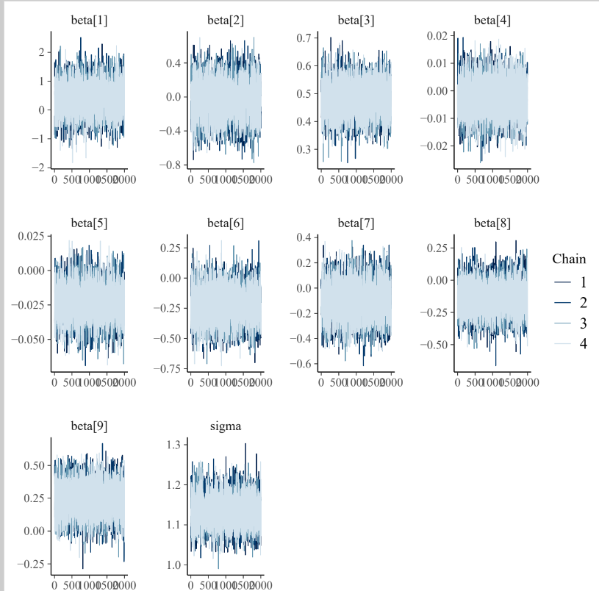

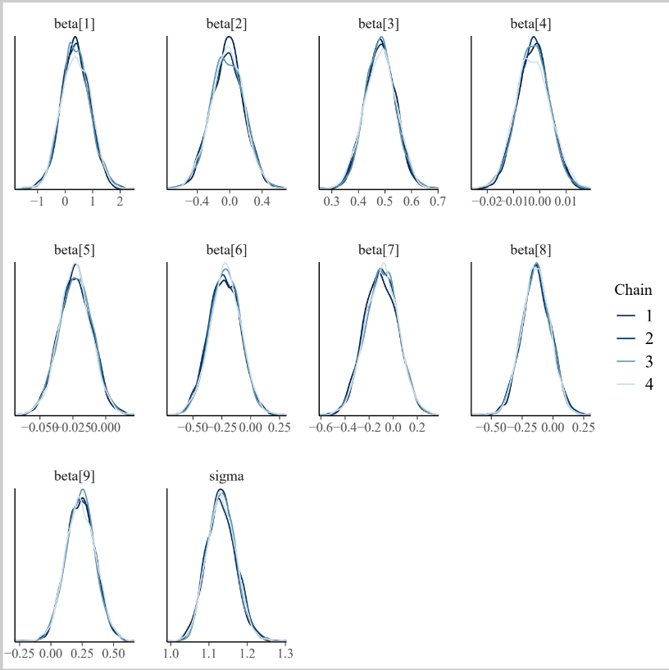

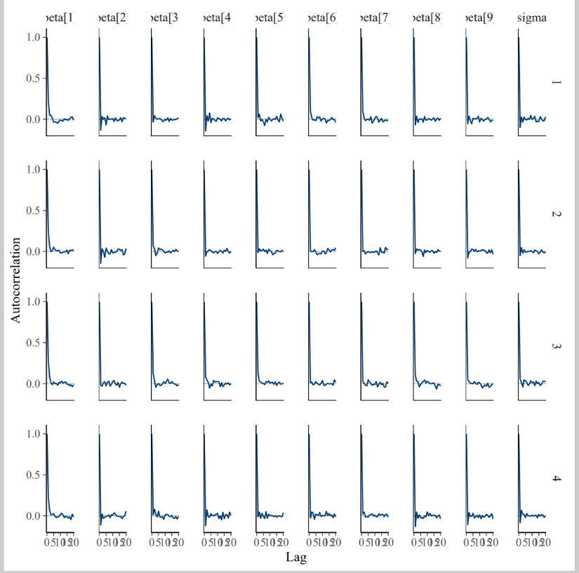

**Viral Load adjusted+ADH**

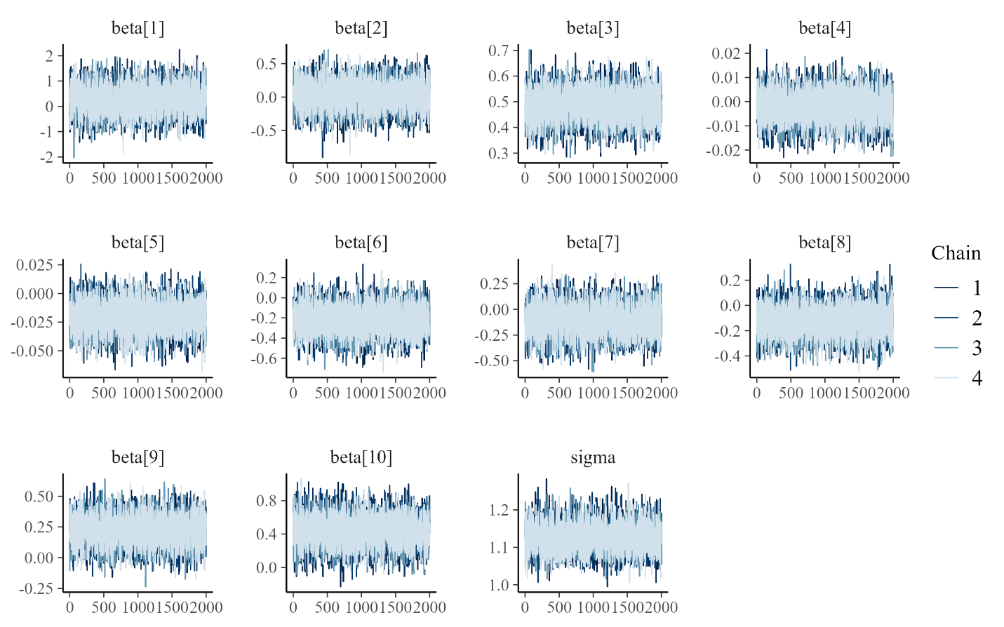

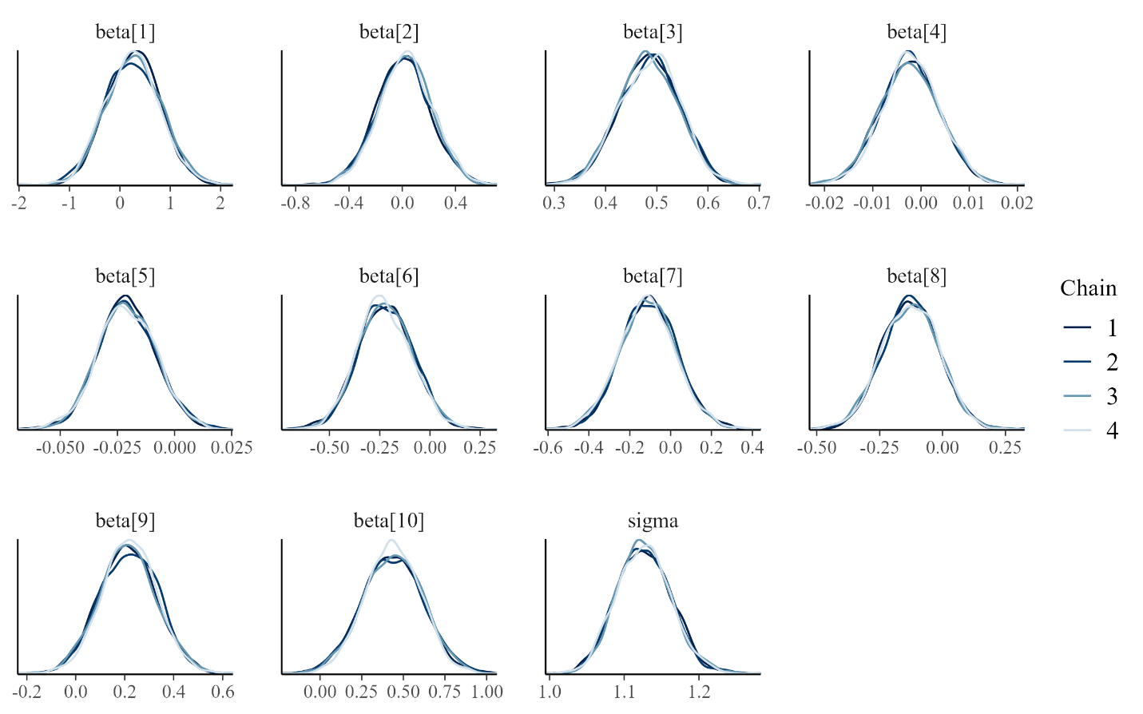

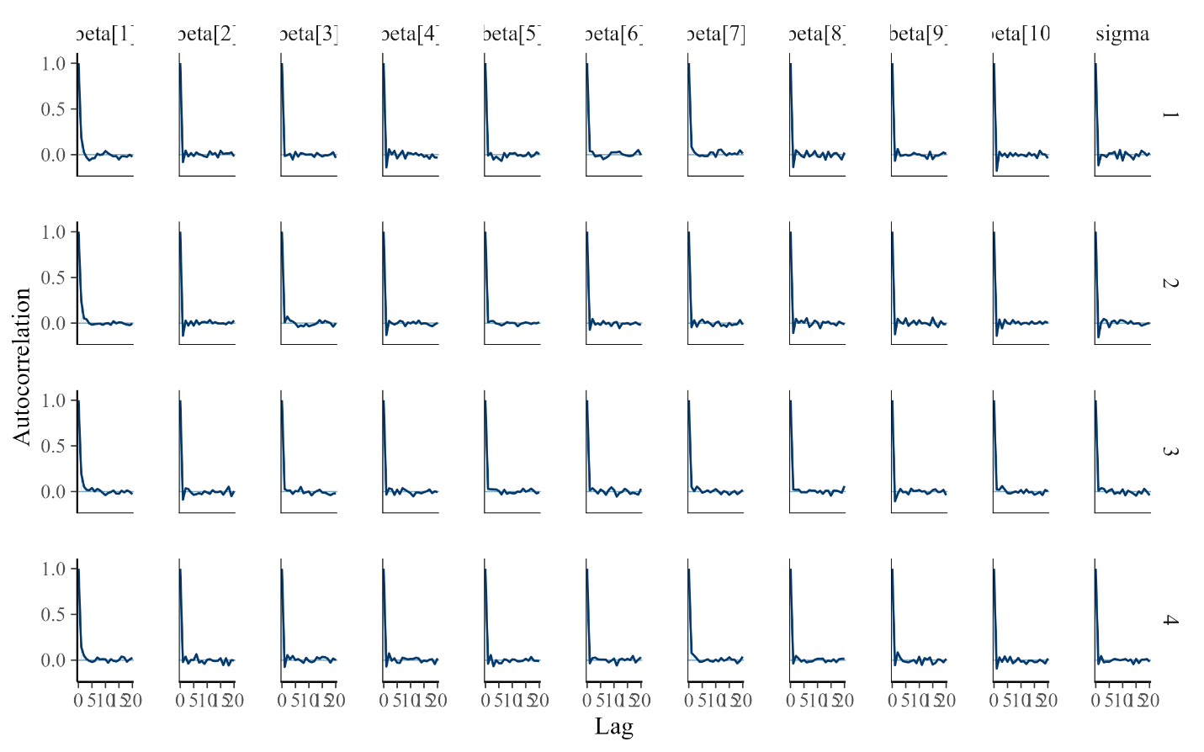

**CD4 Adjusted**

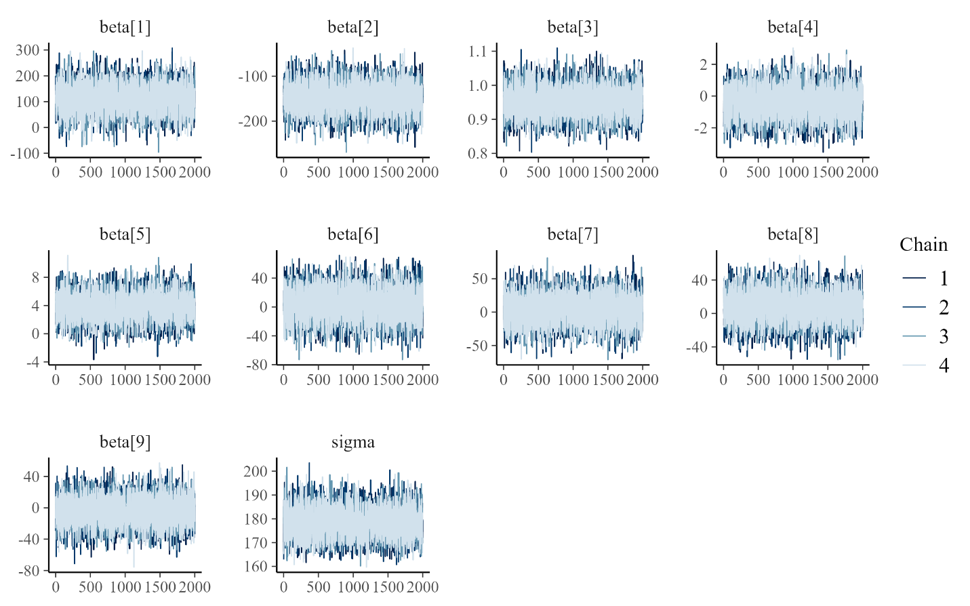

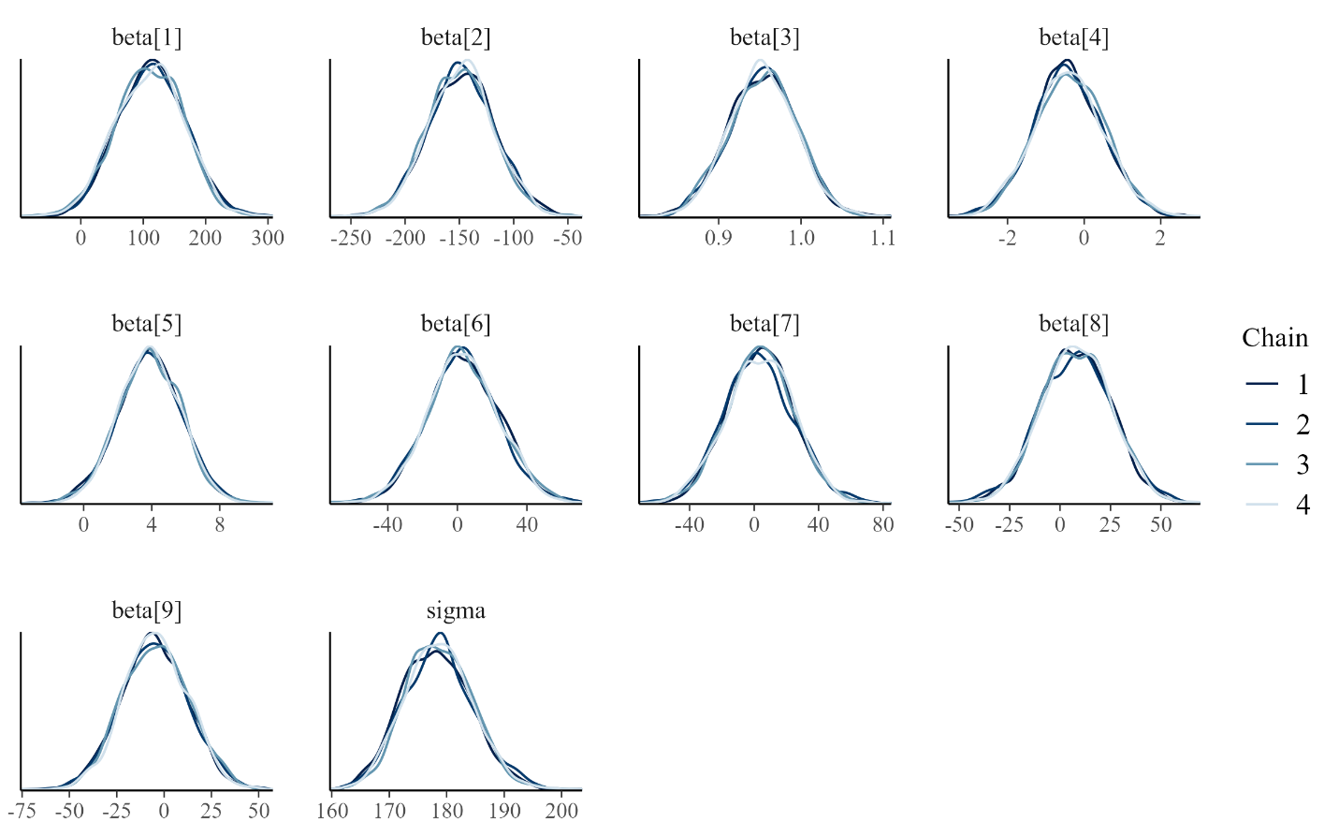

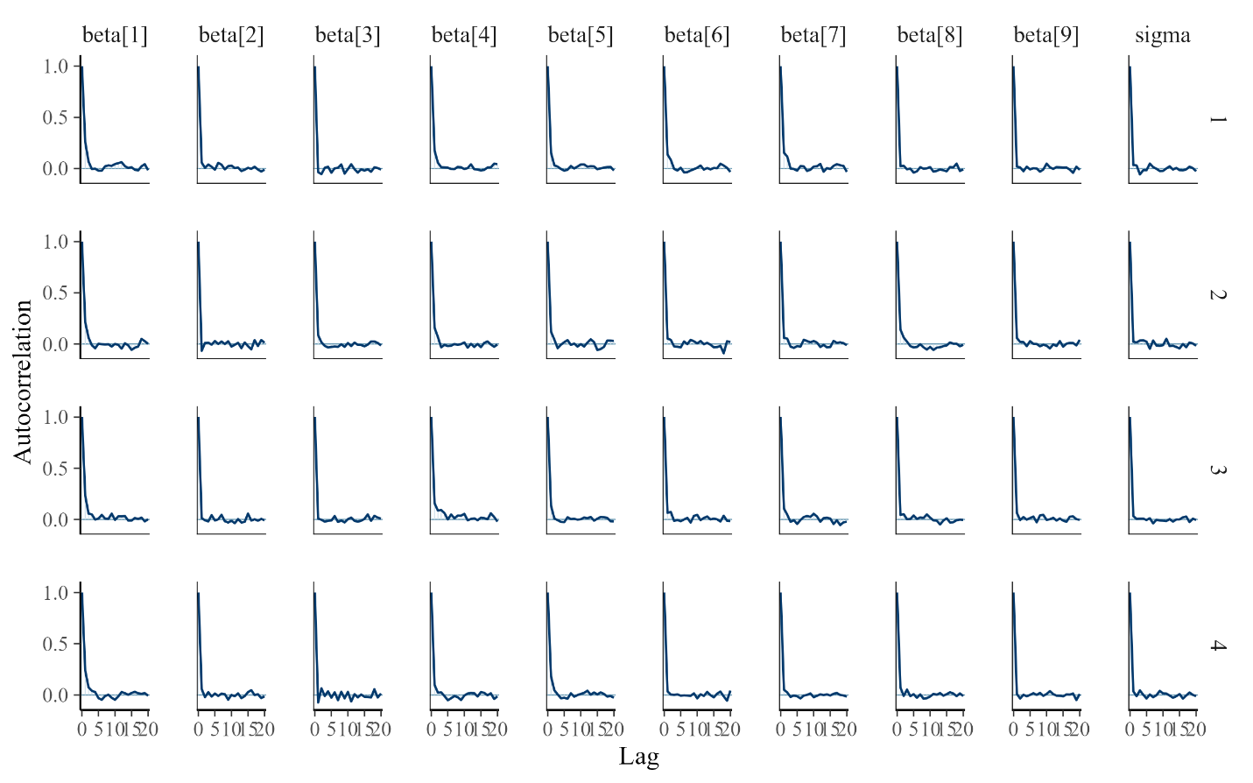

**CD4 Adjusted+ADH**

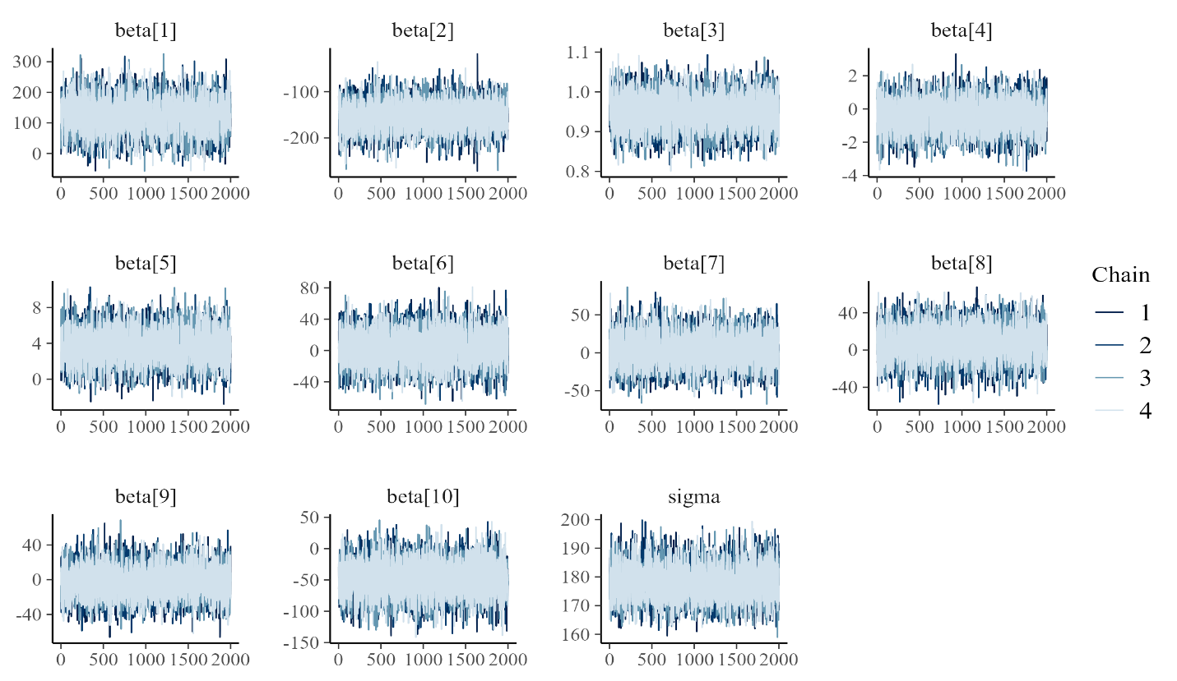

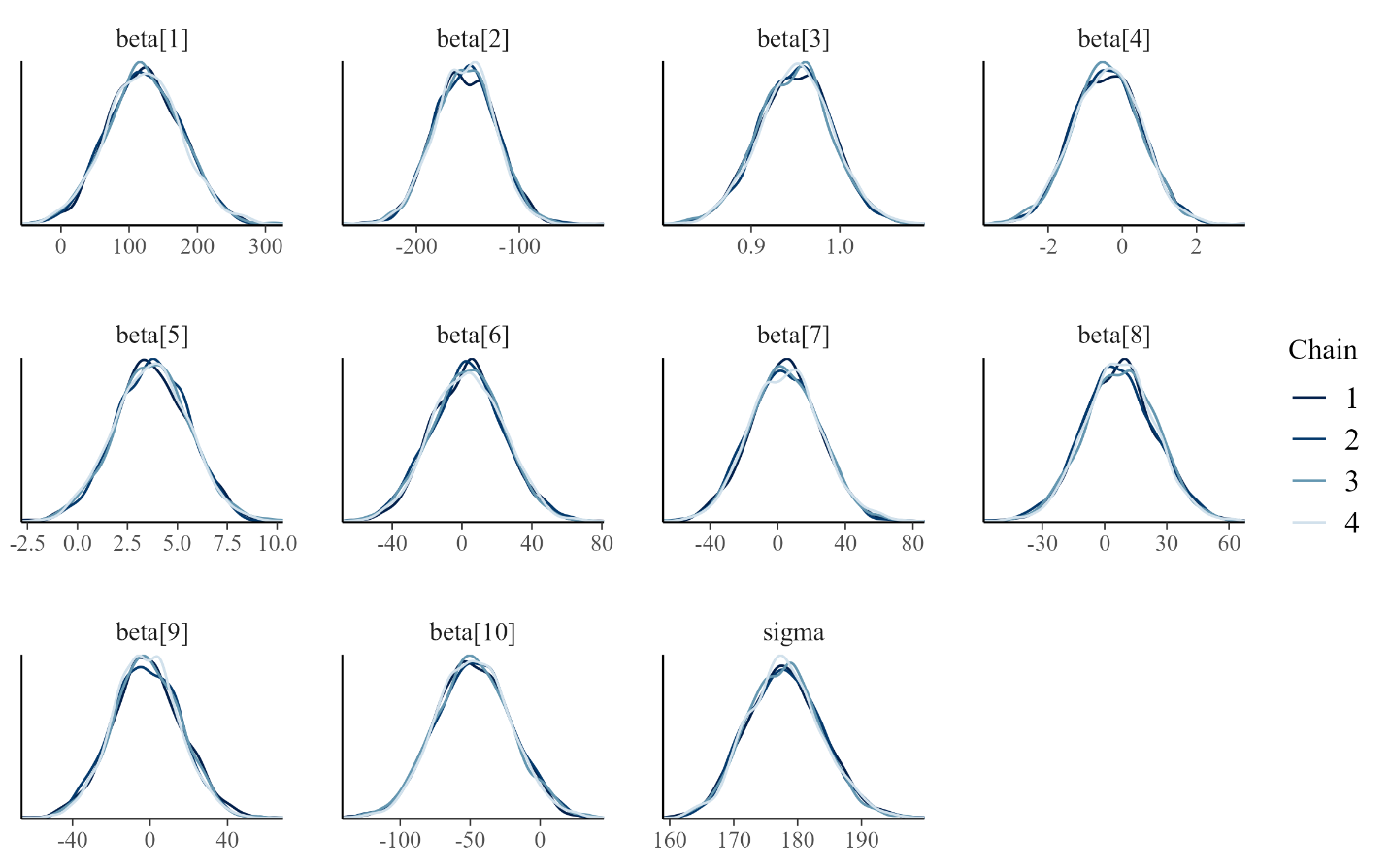

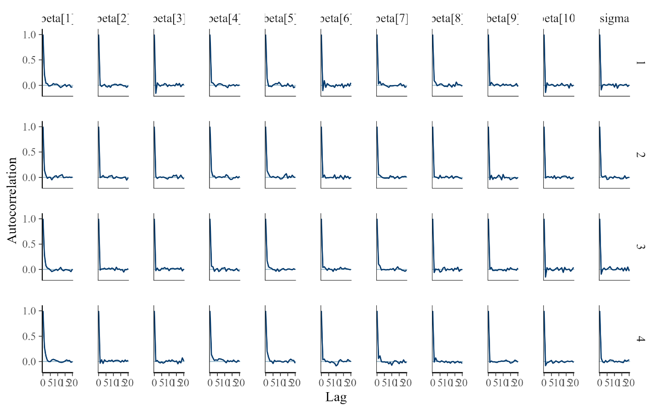

**Physical Adjusted**

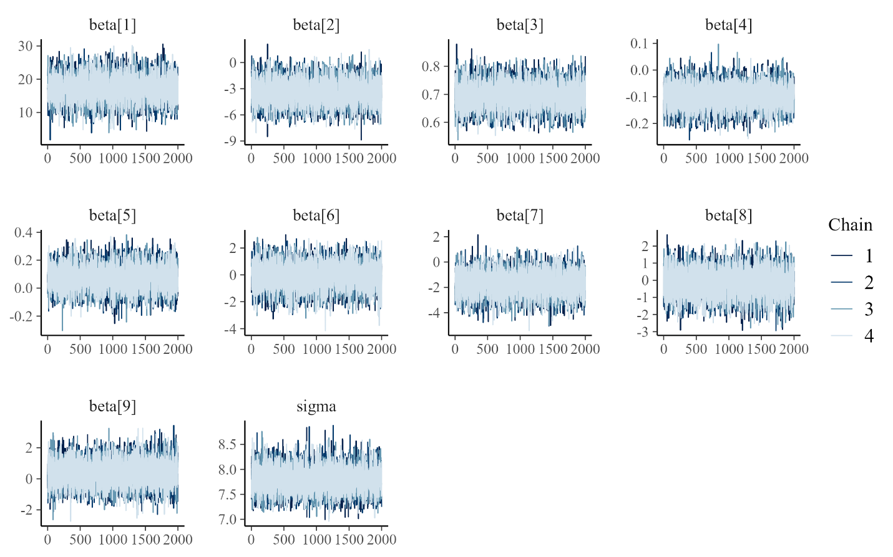

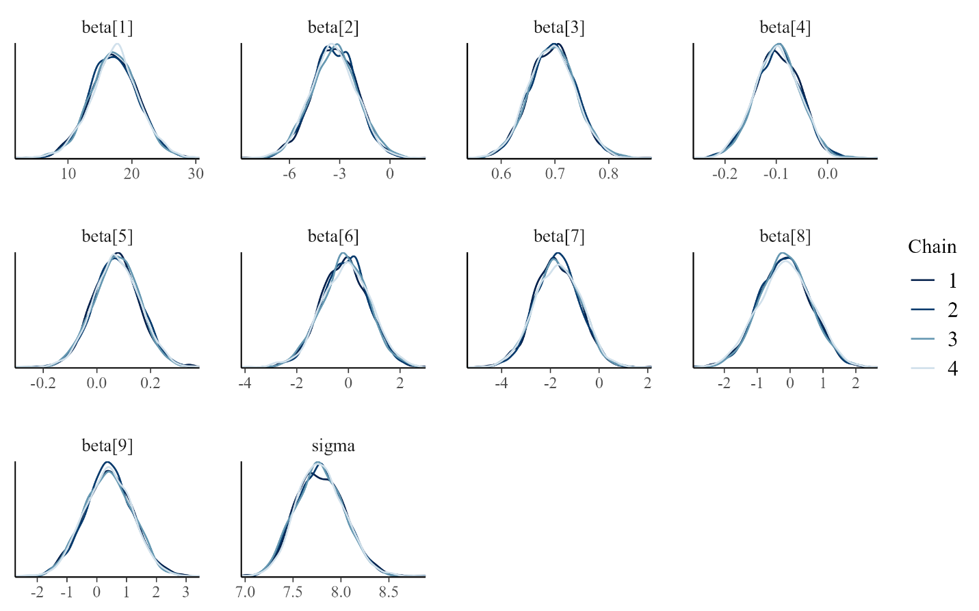

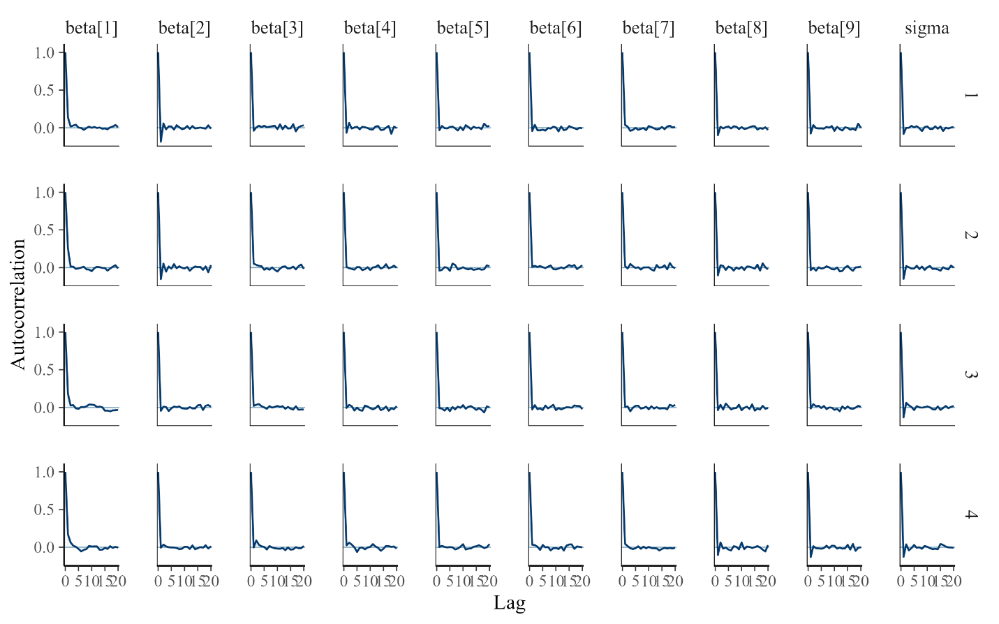

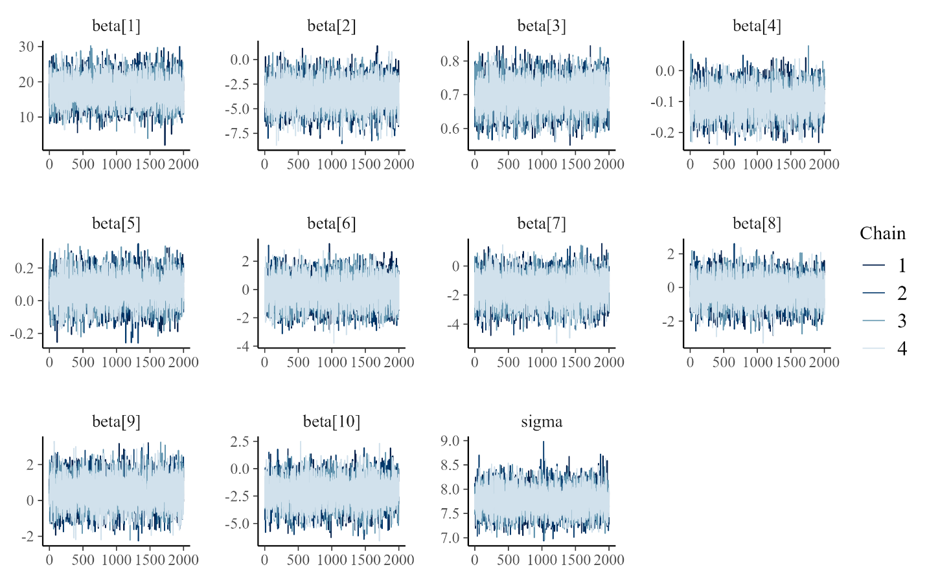**Physical Adjusted+ADH**

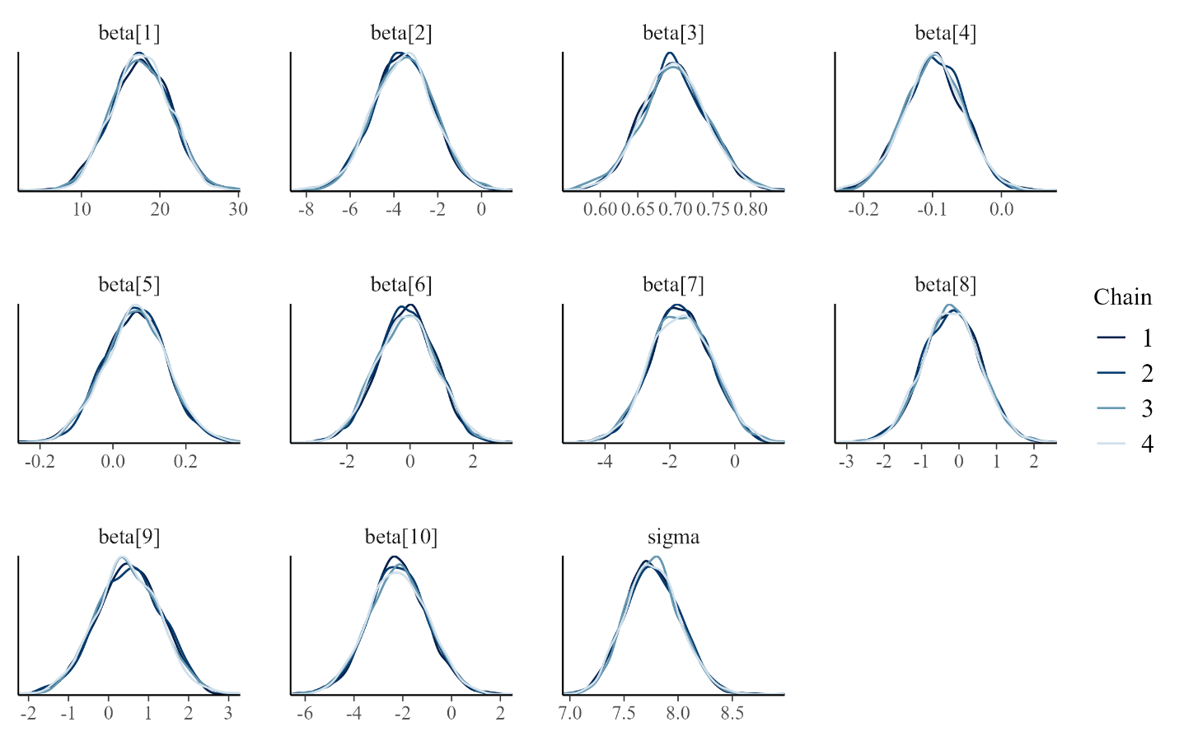

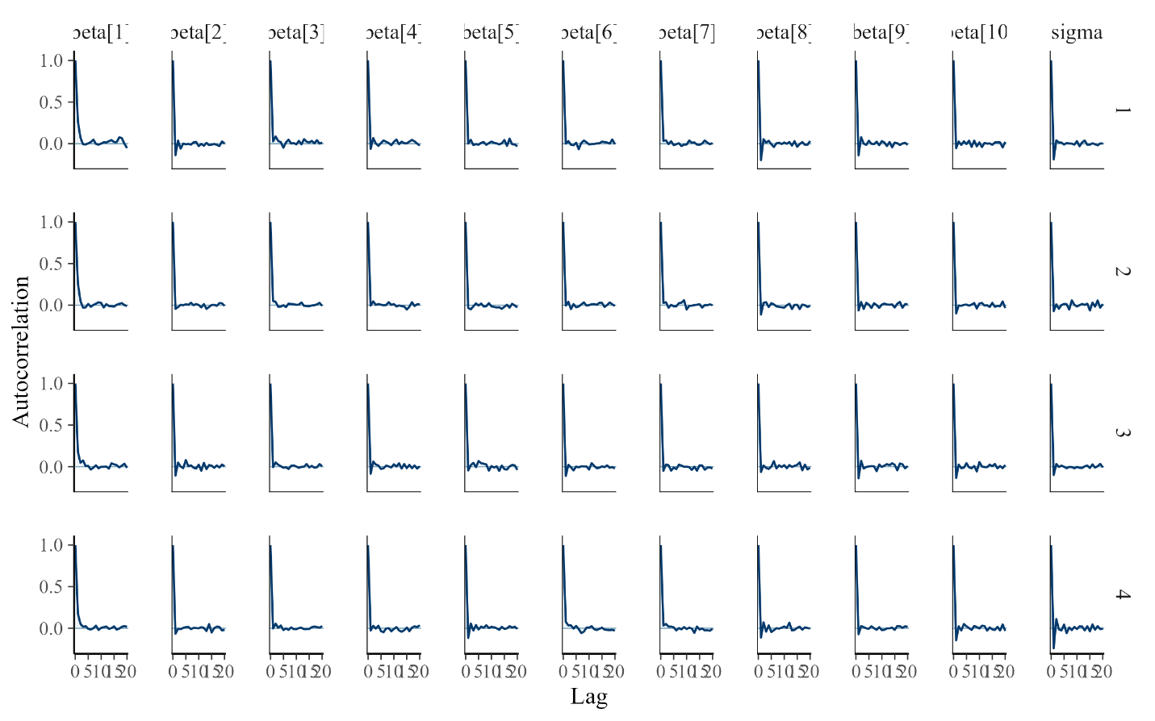

**Mental Adjusted**

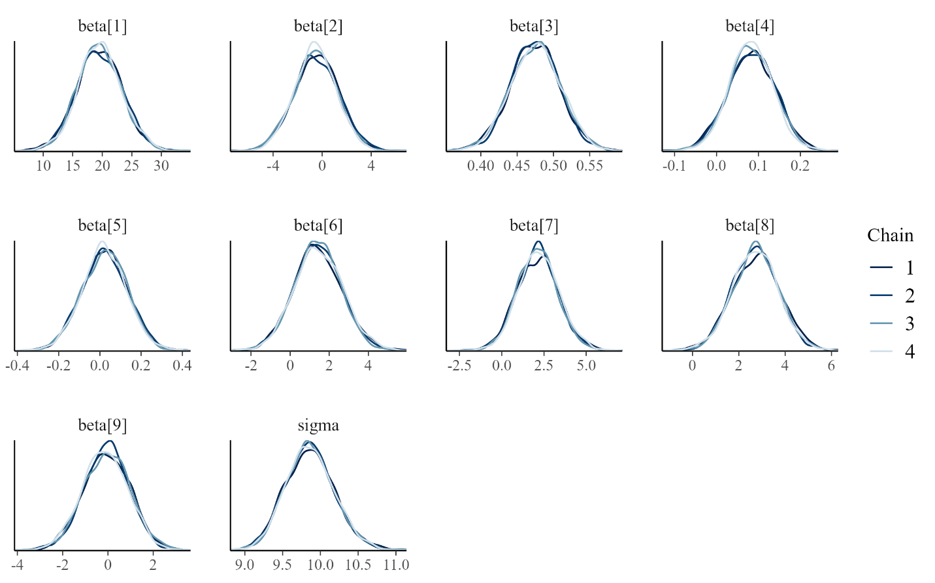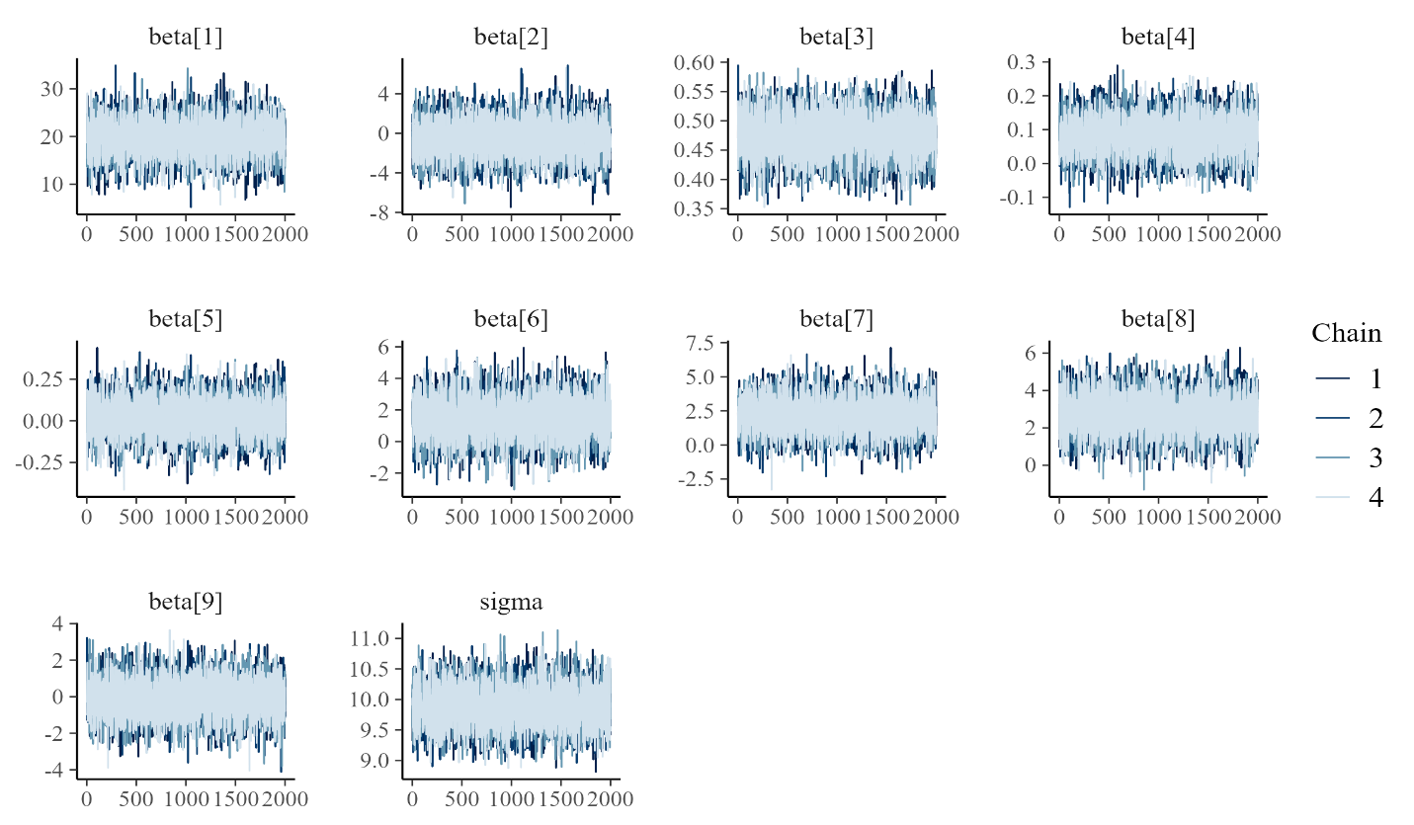

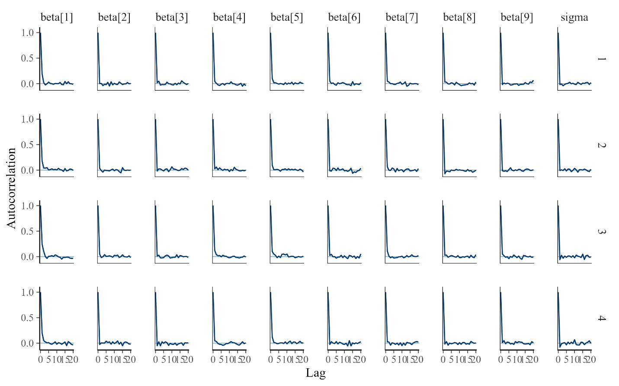

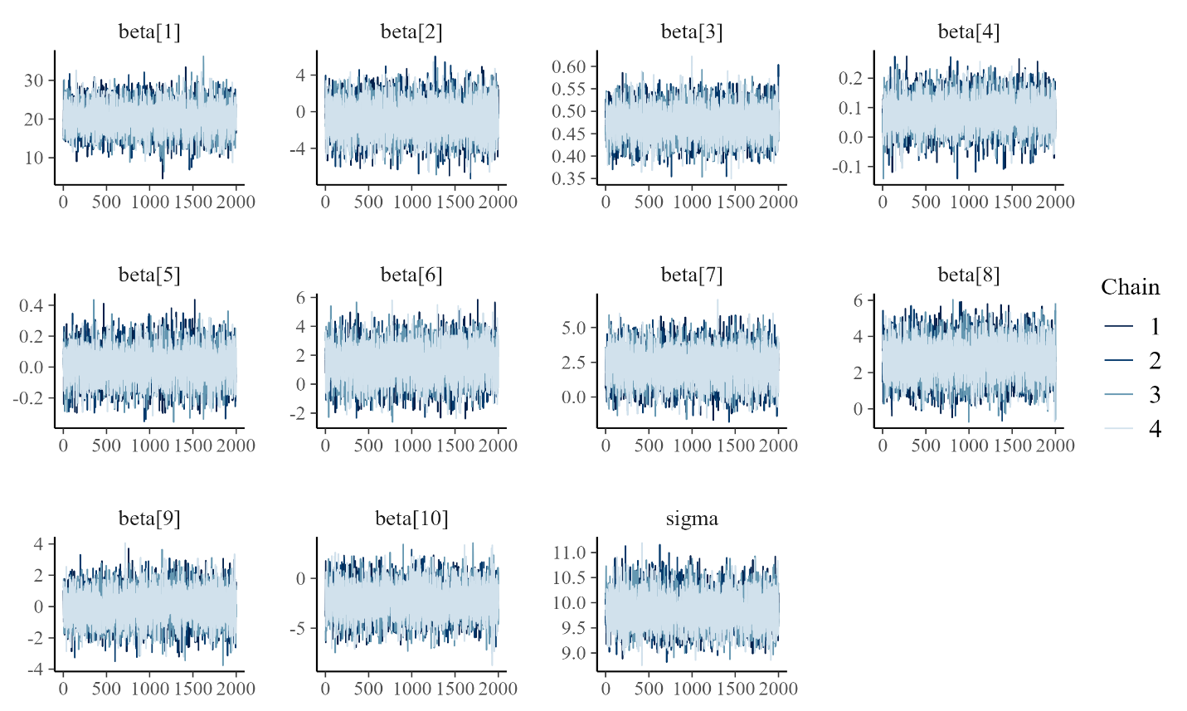**Mental Adjusted+ADH**

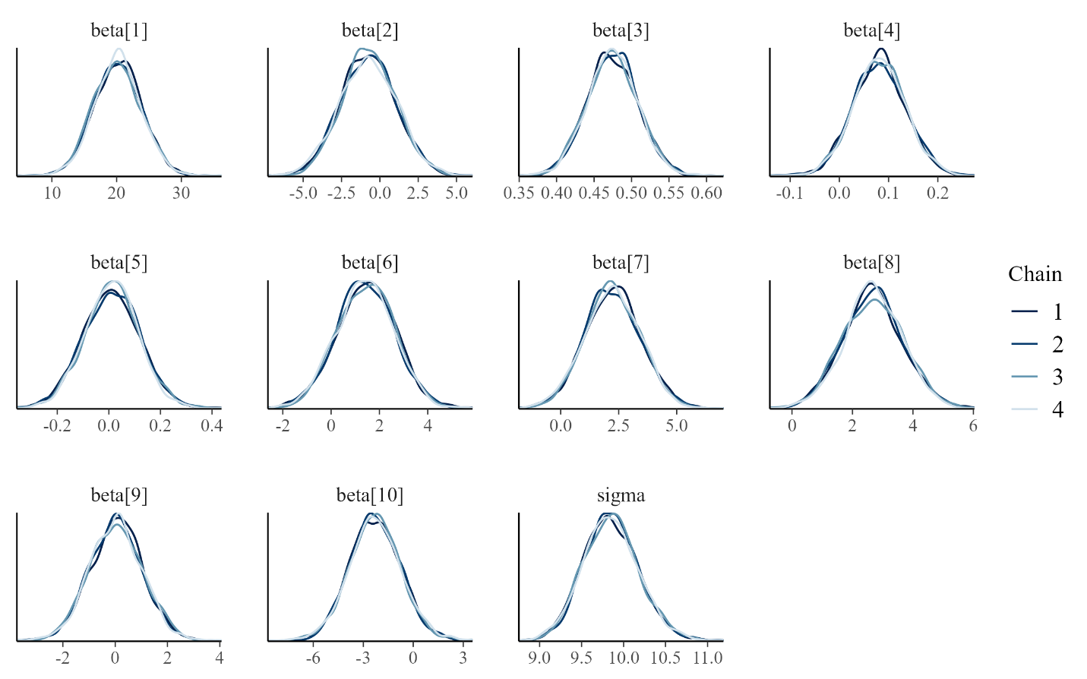

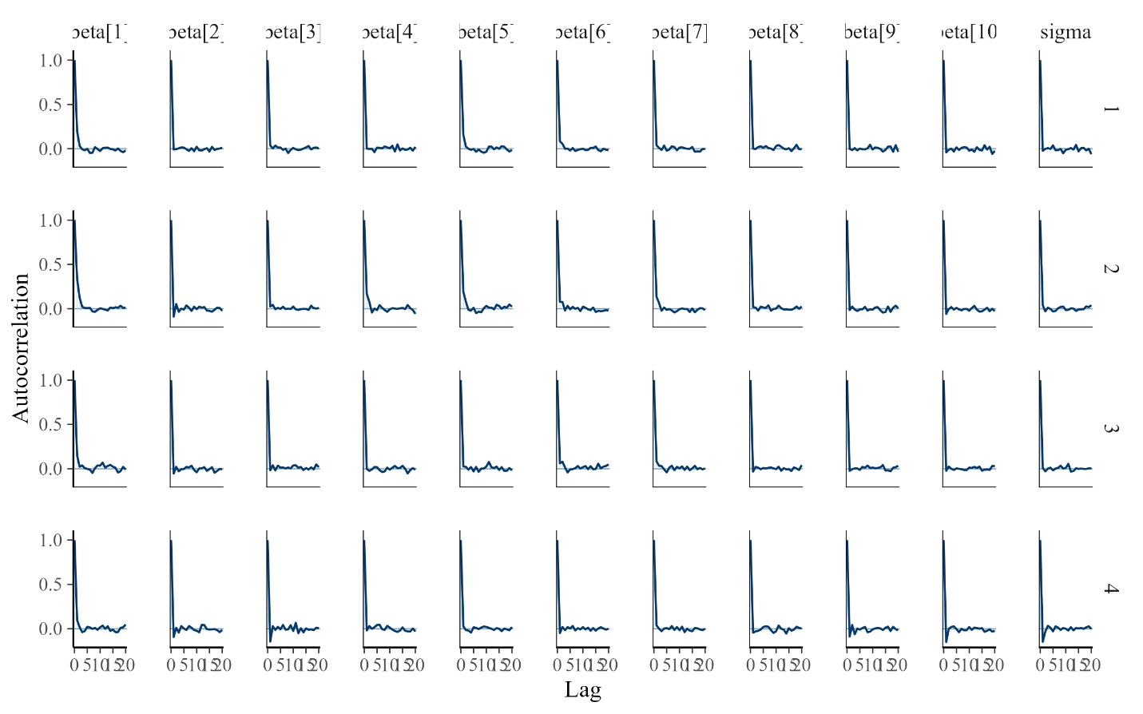

**Table A2. Convergence Diagnostics for the Hard Drug Use Effect (β₂) in Bayesian Linear Regression Models**

This table presents convergence diagnostics for the regression coefficient corresponding to baseline hard drug use (β₂) across all Bayesian models. Reported metrics include the Gelman–Rubin convergence statistic (R̂), bulk effective sample size (Bulk ESS), and tail effective sample size (Tail ESS), as obtained from CmdStanR. R̂ values near 1.000 indicate adequate mixing and convergence of Markov chains. Bulk ESS reflects sampling efficiency for estimation of posterior means, whereas Tail ESS reflects efficiency for estimation of posterior tail quantities. All models were estimated using four chains with 2,000 post-warmup iterations per chain. No divergent transitions were detected.

|  |  |  |  |  |
| --- | --- | --- | --- | --- |
| **Outcome** | **Model** | $$\hat{R}$$ | **Bulk ESS** | **Tail ESS** |
| Log10 Viral Load at Year 2 | Adjusted | 1.002 | 9936.595 | 5861.548 |
| Log10 Viral Load at Year 2 | Adjusted+ADH | 1.001 | 8913.728 | 5964.003 |
| CD4 Count at Year 2 | Adjusted | 1.000 | 7700.984 | 6227.57 |
| CD4 Count at Year 2 | Adjusted+ADH | 1.000 | 7700.984 | 6227.504 |
| Physical QOL at Year 2 | Adjusted | 1.000 | 9315.926 | 5203.923 |
| Physical QOL at Year 2 | Adjusted+ADH | 1.000 | 9572.266 | 5747.104 |
| Mental QOL at Year 2 | Adjusted | 1.001 | 7729.578 | 5372.155 |
| Mental QOL at Year 2 | Adjusted+ADH | 1.000 | 8950.451 | 5711.461 |